

**FPT International School**

**---o0o---**

**PROJECT REPORT**

**<OceanGate>**

Batch :T2004M

Semester :1

Group :4

1. TH2002015 Nguyen Trung Hieu (Student1263864)
2. TH2003011 Tran Xuan Hiep (Student1266913)
3. TH2003003 Do Thi Ngan (Student1266587)
4. TH2002025 Nguyen Huu Tuan Anh (Student1263822)

**Faculty**: Dang Kim Thi

**Ha Noi-09/2020**

**OceanGate**

**Table of Contents**

1 .Problem Definition 3

* 1. Overview 3

1. Introduction 3
2. Implementation Environment 3
   1. User Stories 4 Customer 4
3. Log in 4
4. Register 4
5. Search by name 4
6. View the descripton of each product 4

2. Follow chart 5

2.1 GUI 1:Login 5

2.2 GUI 2:Registe

2.3 GUI 3:Search by names 6

2.4 GUI 4: View descripton of each product 7

3. UI/UX 8

3.1 Homepage 9

3.2 Product

3.3.1 Product-listing (cd-rom) 9

3.3.2 Product details (cd-rom) 10

3.4.1 Product-listing-2(blu-ray drive) 11

3.4.2 Product details-2 (blu-ray drive) 12

3.4 Whishlist

3.5 Compare 12

3.6 About us 13

3.7 Contact us 14

3.8 Store 15

3.9 Support 16

3.10 Cart 17

3.11 Login 18

4. Summary 19

1. Problem Definition
   1. Overview
2. Introduction

**Requirement Specification:**

We have a team of 4 people who have created a website to sell fans. You know that with the current 4.0 trend, most people will buy on the website more. So we created A website that addresses consumers' problems is a website for production of the storage devices/disks which are becoming

popular as days pass by due to the excellent quality, fast delivery on purchases and efficient after sales Services.

Oceangate products have become so popular that the demand for the products is not

only coming from local market but also international market.

We create user interaction with the website so that users can use them easily and The websites are linked together consistently and can be used in any type of website devices such as laptops, tablets, phones, and websites also run smoothly on applications such as Chrome, IE, Firefox, etc.

**The Web site is to be created based on the following requirements.**

1) The Home Page should be created making use of Frames with a suitable logo

2) The site should display a menu which will contain the options for brief

introduction about the various products available, location of the shop and

any other information if required.

3) The information should be categorized according to the brand names of the

products like if a User wants to see only Samsung products then he click on a

Link/button/menu etc and he will see only That Brand products.

4) When a user selects any particular brand, a list of products for that brand will

be displayed

5) A brief summary of features of individual products should be displayed on the

Web Page along with the product but detailed Features should be stored in

Individual Word documents which can be downloaded or viewed by the User

who wishes to see the same.

6) The user should also be able to compare the various products of different as

well as similar brands.

7) There should be a “Contact Us” page which will have the Address of the

Company which is as follows and the mail address which when clicked will

invoke the local mail client from where they can send an email. Address of the

Company should be displayed using GeoLocation API (eg. GoogleMaps).

1. **Implementation Environment**

* HTML5/ CSS/ JavaScript
* Boostrap / Jquery
* Amazing Slider
* Dreamweaver
* Google Chrome/ Mozilla FireFox/ Internet Explorer
* Methodology: Scrum

**1.2User Stories**

**Customer**

* + 1. Log in

As a customer , I want login to the website

* + 1. Register

As a customer , I want register to the website

* + 1. Search by name

As a customer , I want search the products by their name

* + 1. View the description of each product

As a customer , I want contact to admin

2. Follow chart

flowchart - GUI 1: Login

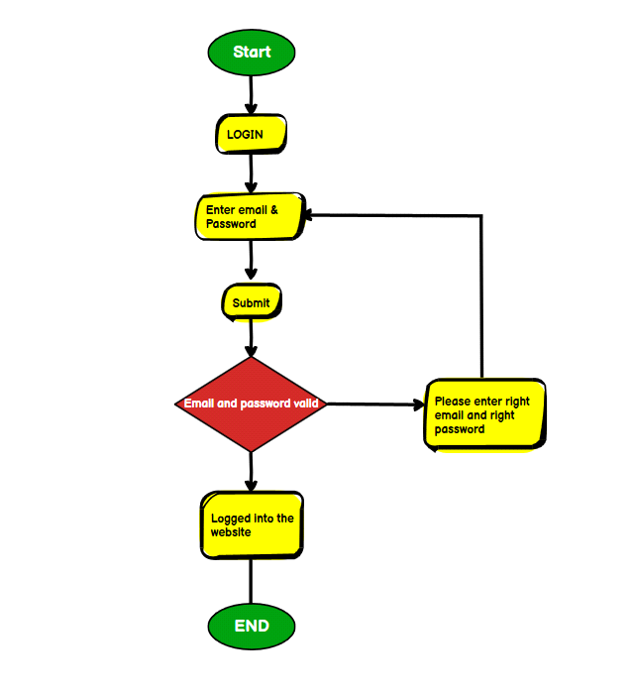

flowchart- GUI 2: Register

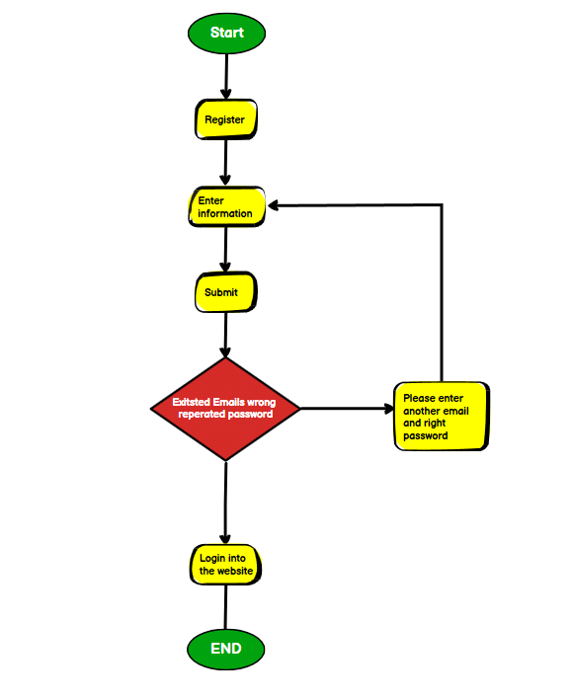

flowchart - GUI 3: Search by names

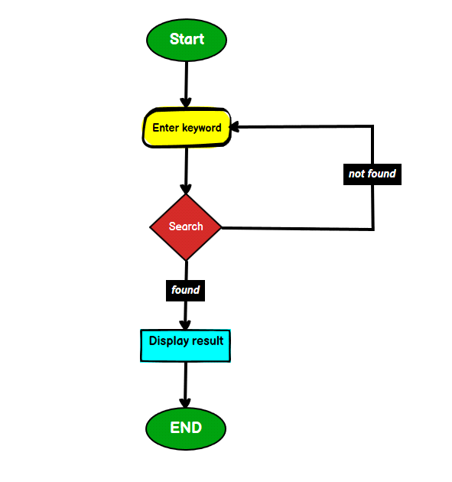

flowchart- GUI 4: View descripton of each product

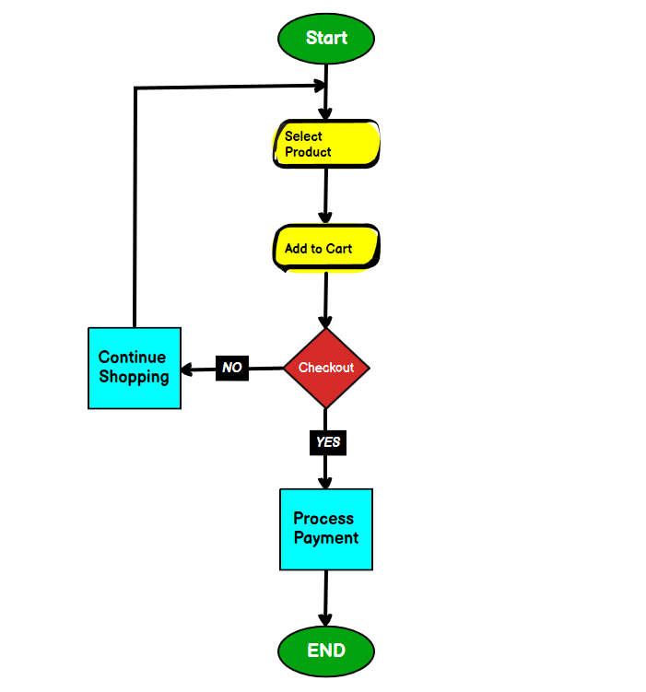

**3. UI\UX**

**3.1 Homepage**

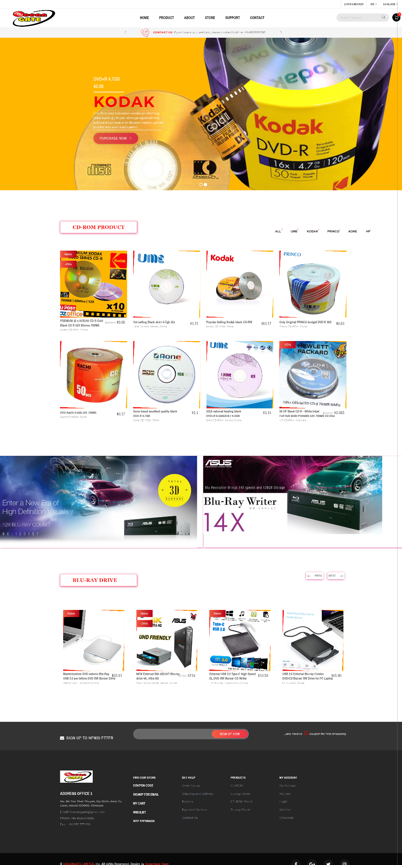

**3.2 Product-listing**

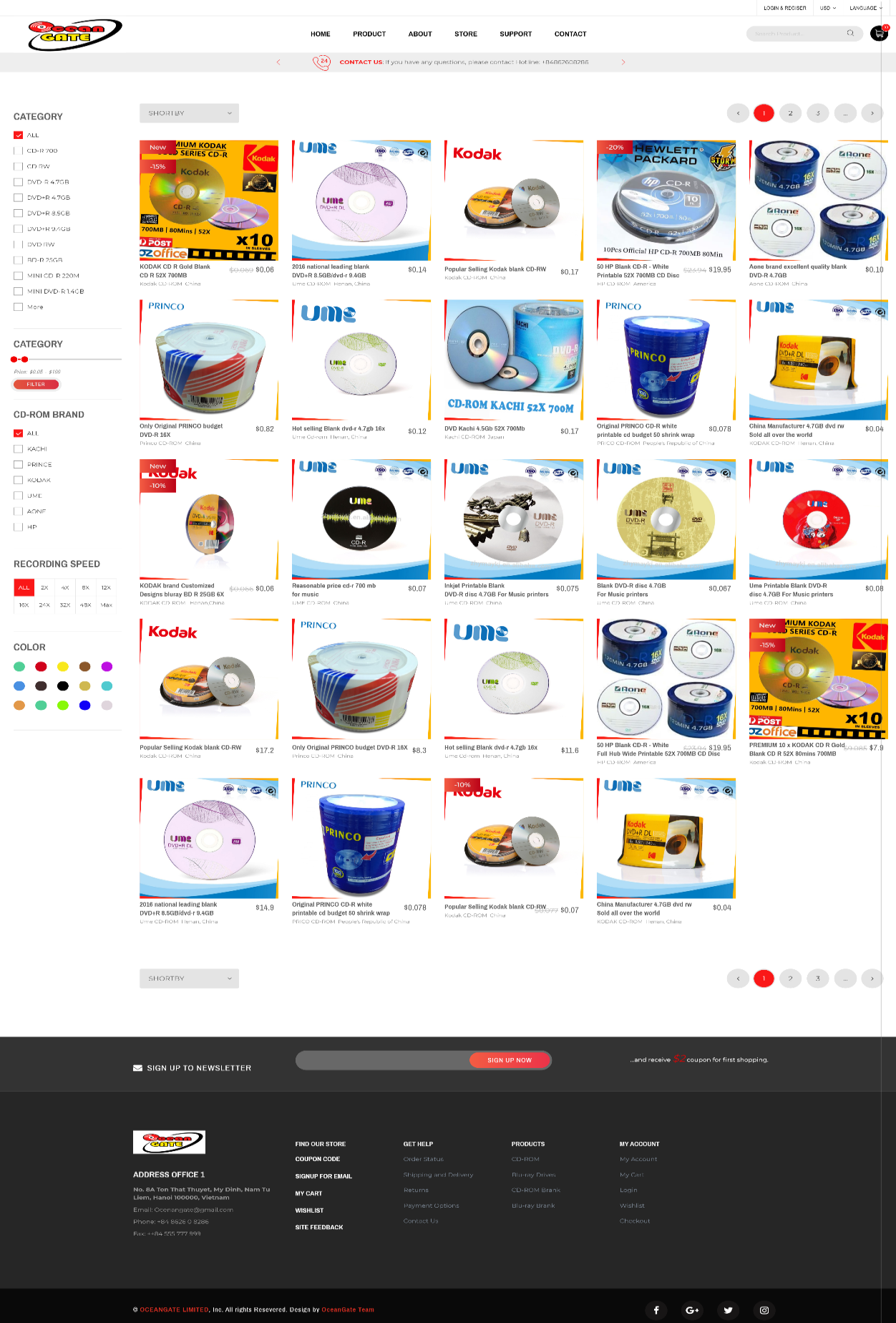

**3.3.2 Product Details**

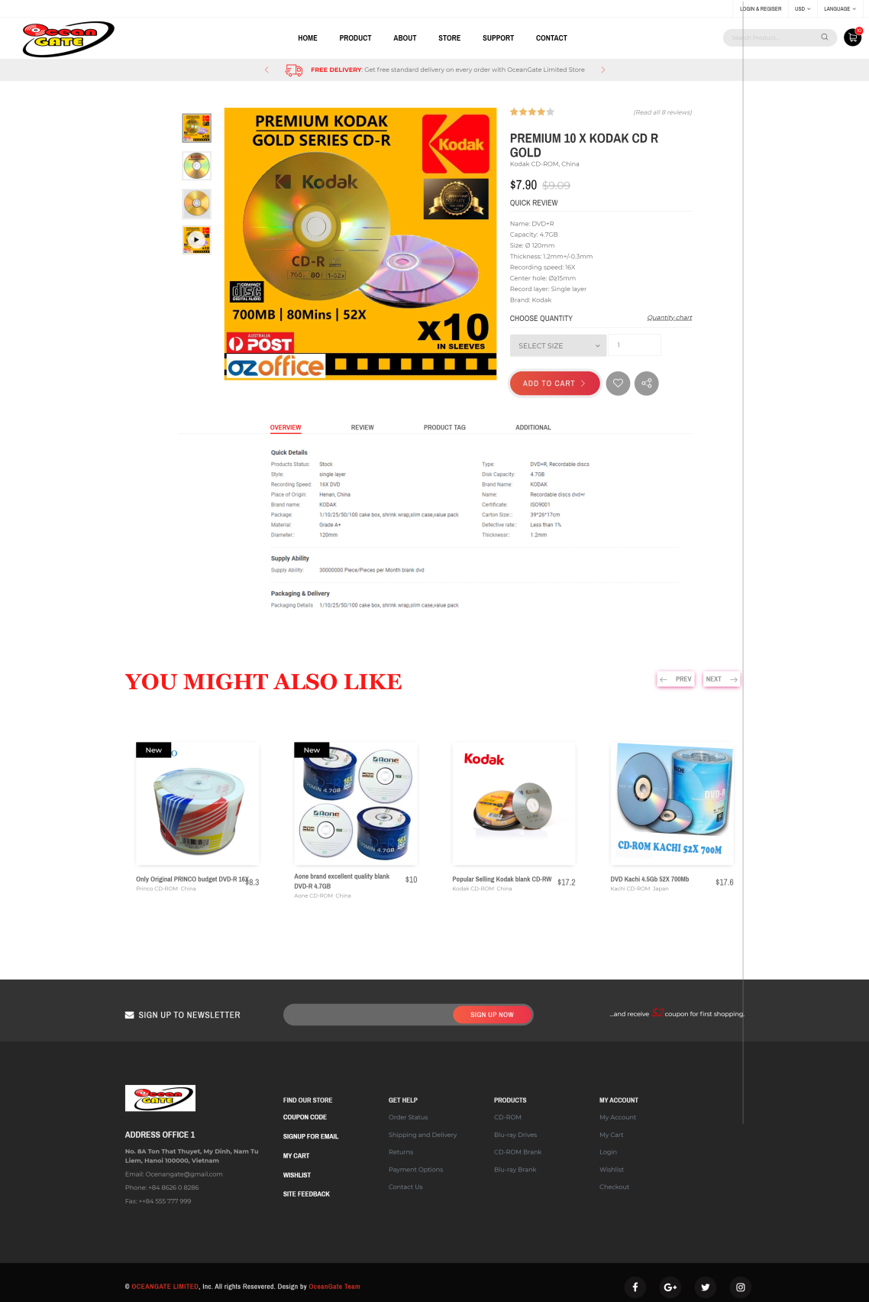

**3.4.1 Product-listing-2**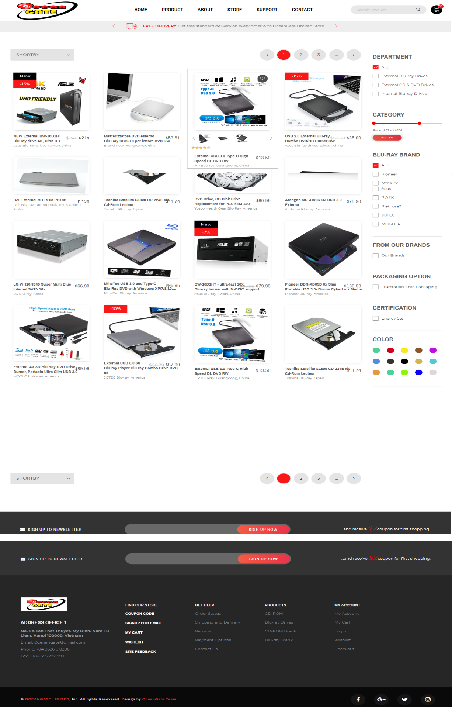

**3.4.2 Product-details-2**

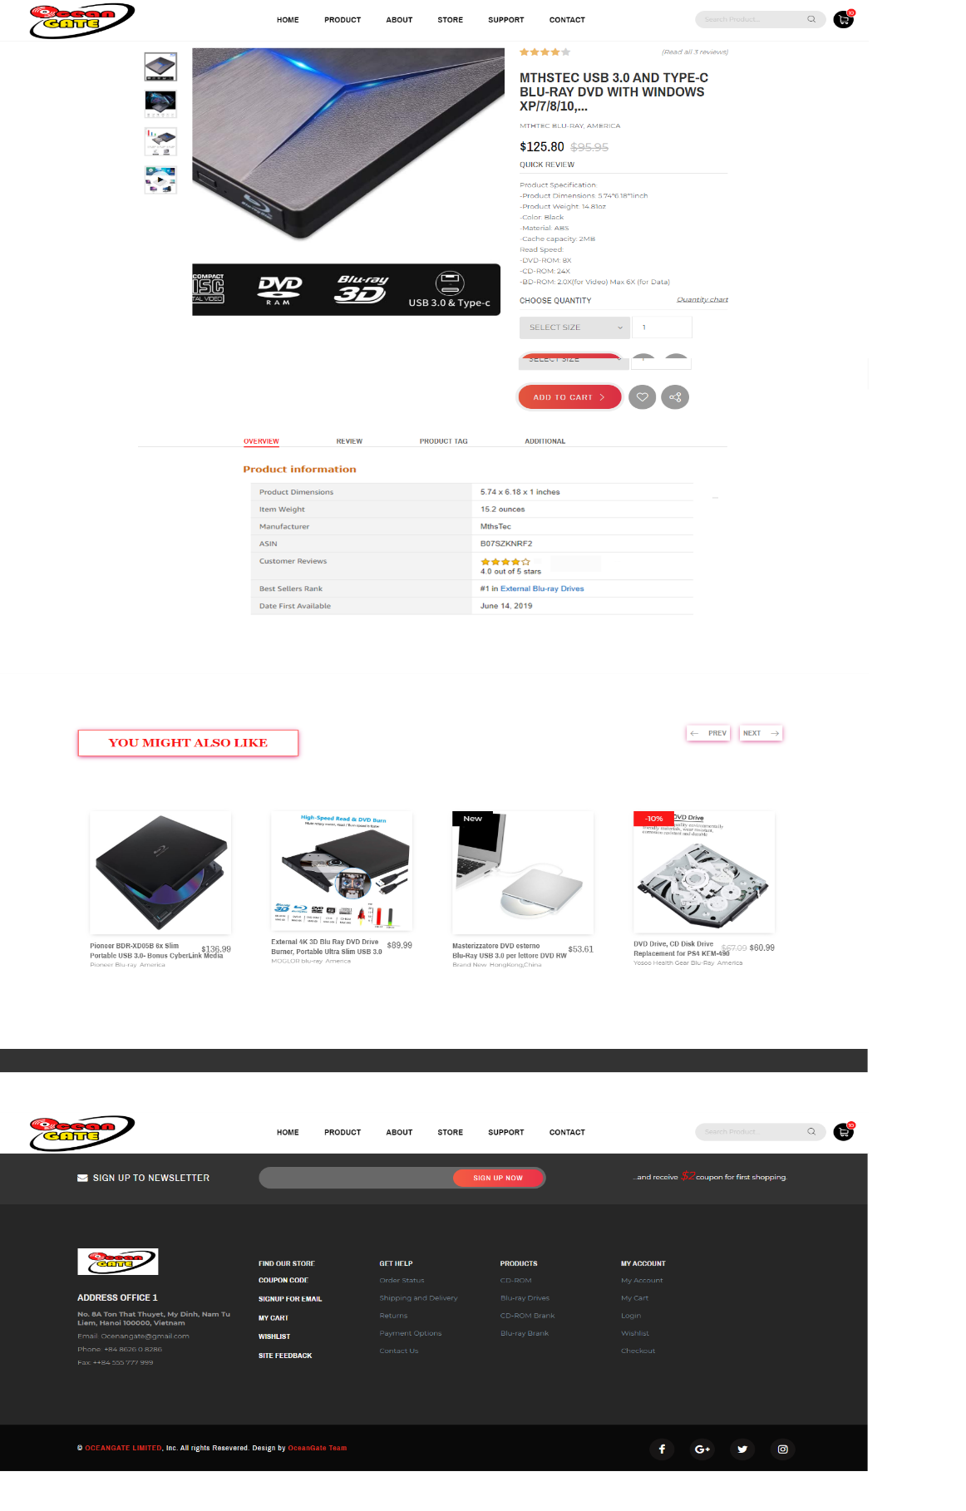

**3.5 Whishlist**

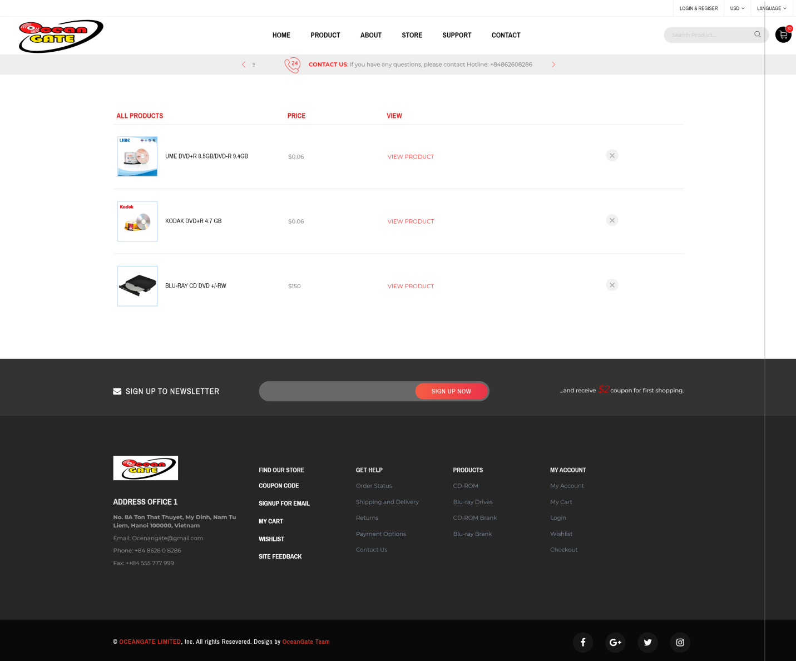

**3.6 Compare**

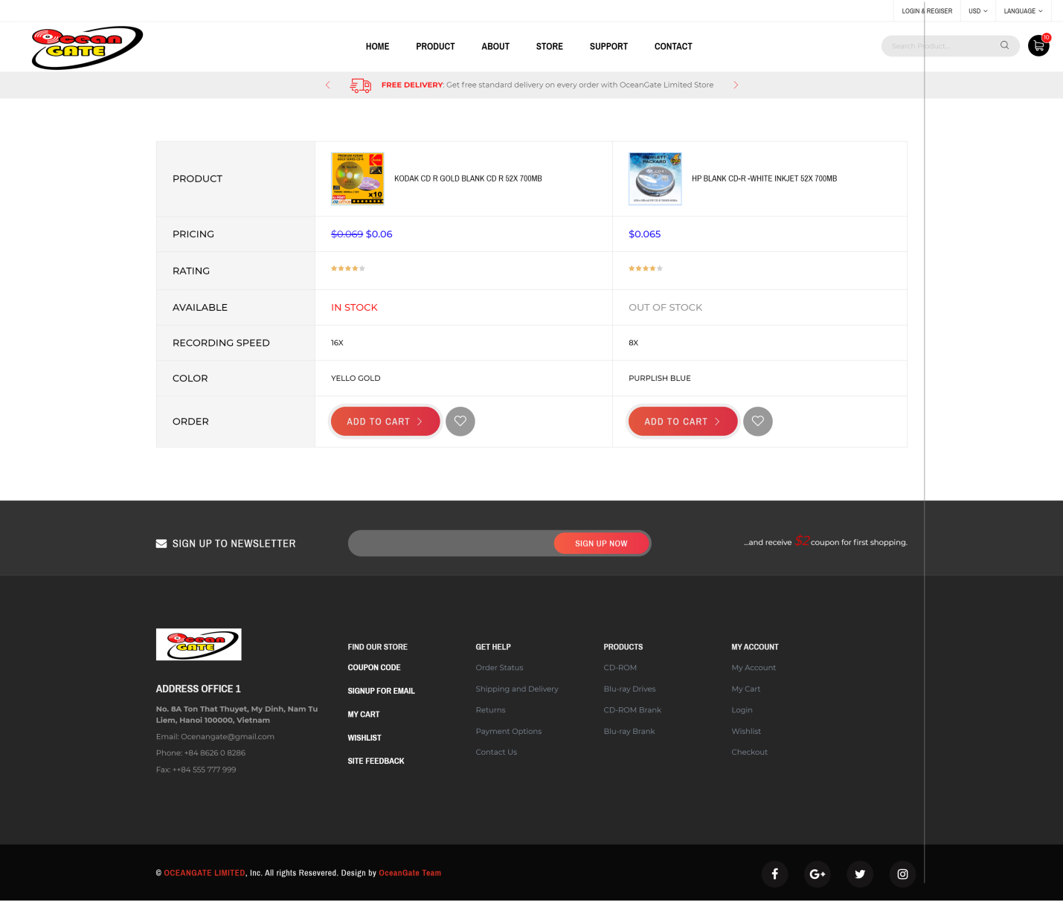

**3.7 About**

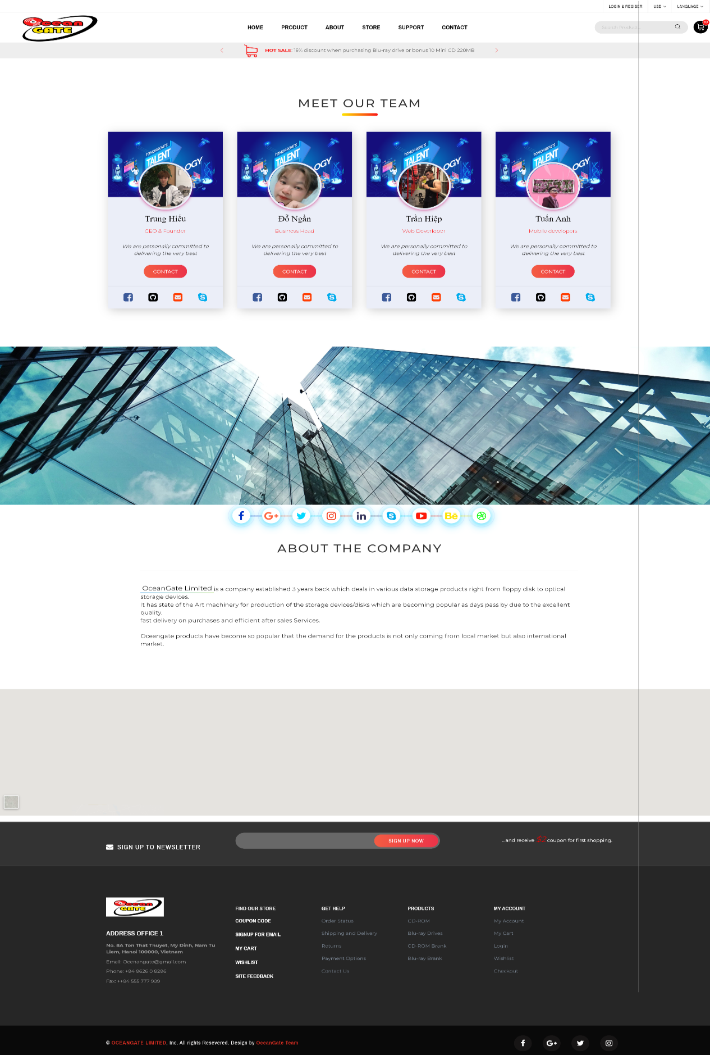

**3.8 Store**

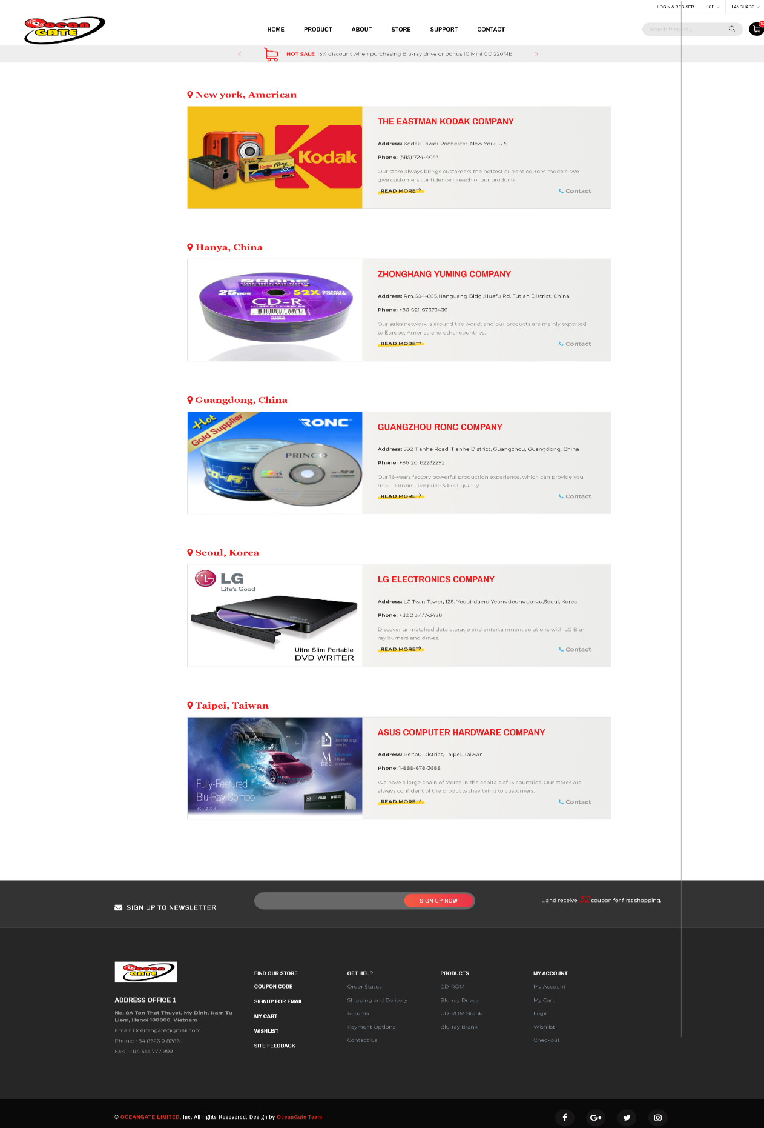

**3.9 Support**

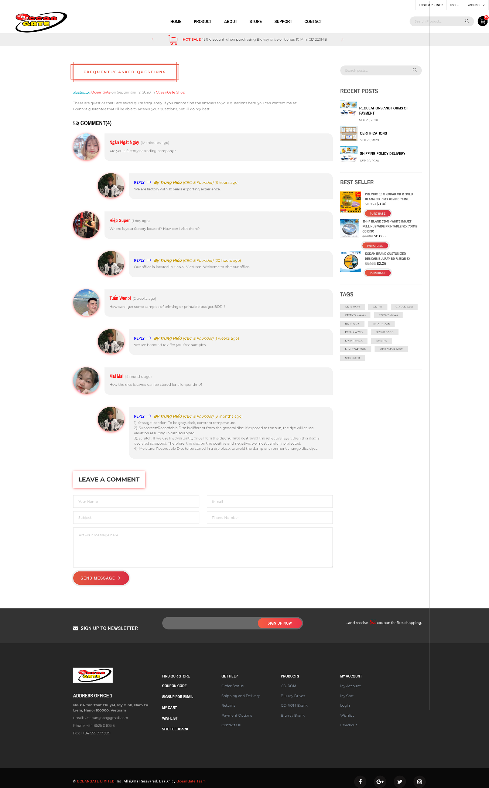

**3.10 Contact**

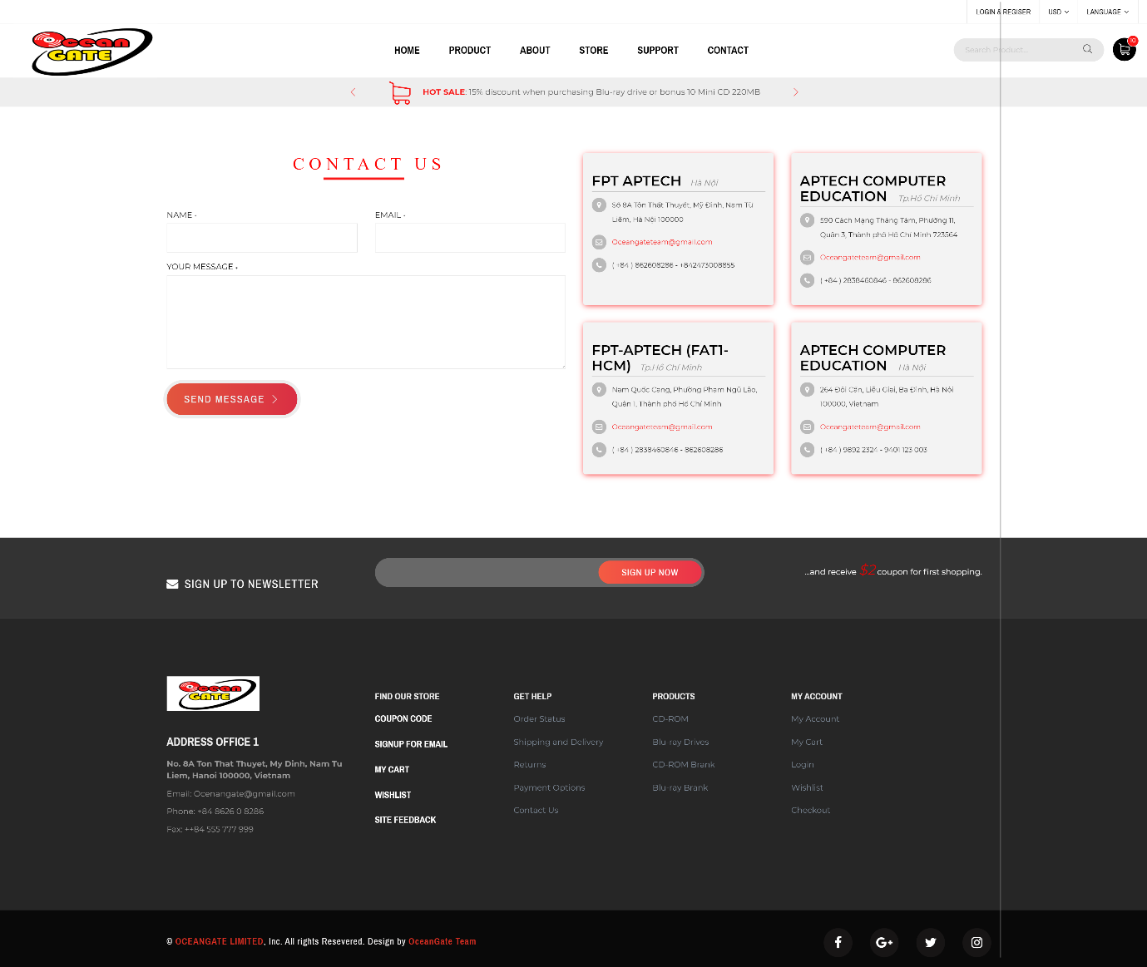

**3.11 Cart**

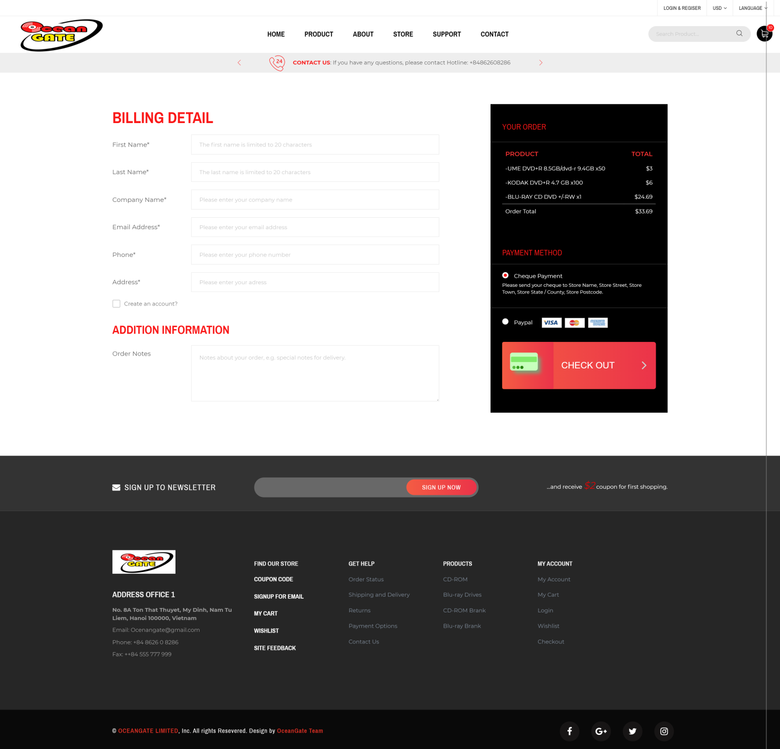

3.12. Login

Sign In

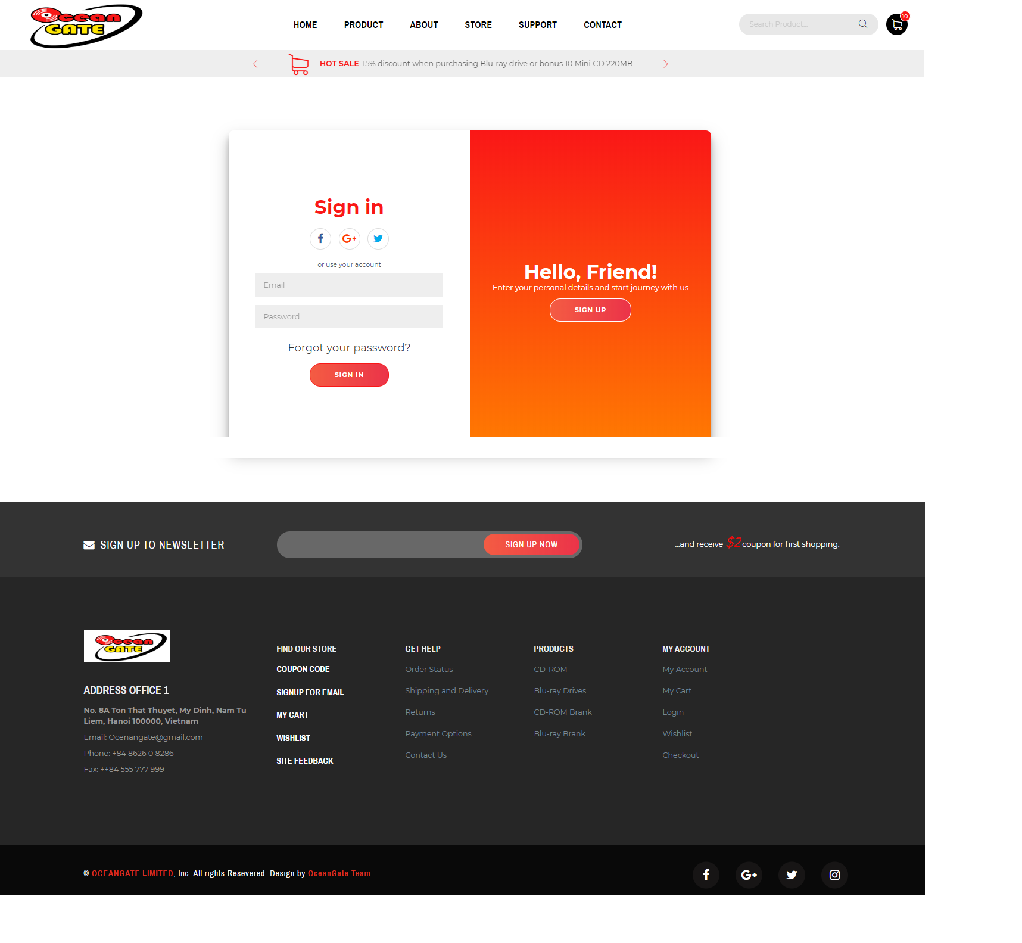

Sign up

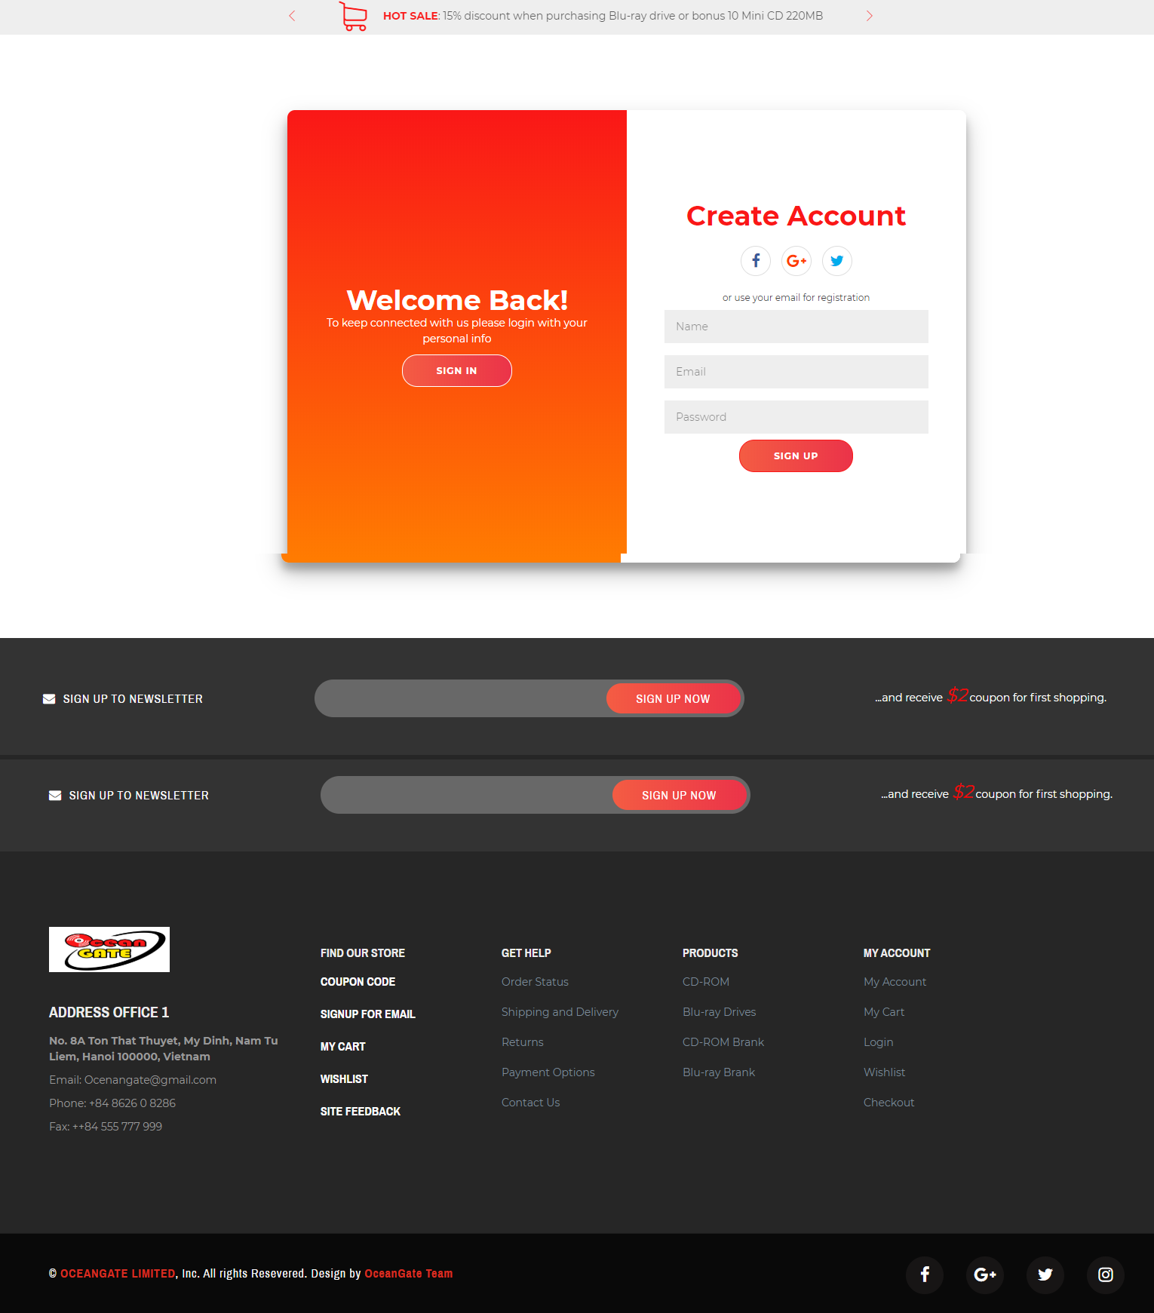

**4. Sumary**

The (x) means that person took part in the individual work

For instace : Nguyen Trung Hieu did the Homepage and Header,…

|  |  |  |  |  |  |
| --- | --- | --- | --- | --- | --- |
|  |  | **Nguyen Trung Hieu** | **Do Thi Ngan** | **Tran Xuan Hiep** | **Nguyen Huu Tuan Anh** |
| 1. | Homepage | x |  |  |  |
| 2. | Header | x |  |  |  |
| 3. | Find resources: images and information of CD,… |  | x |  |  |
| 4. | Product details |  |  | x |  |
| 5 | Whishlist |  |  |  | x |
| 6 | Compare |  | x |  |  |
| 7 | Cart |  |  | x |  |
| 8 | About us |  |  |  | x |
| 9 | Contact us | x |  |  |  |
| 10 | Store | x |  |  |  |
| 11 | Support | x |  |  |  |
| 12 | Login | x |  |  |  |